



**Advance Web Engineering**

Component - 1

**Name: - Bishwa Thakuri**

**Student ID: - 77227274**

**L – 6 Section A**

**Introduction**

­For the component-1 we are given sample PHP code form GitHub which is created using HTML, CSS, PHP and JSON. This website manages the detail of book and cd that are submitted by user through the form. The detail contains the book author name, title, price and total number of pages and the cd have the actor name, title, duration and price. To complete the component-1 we are required to add a new table game table which will have the console name, title, price and PEGI. User should also be able to add new product to game table and delete the product. In this document I will be providing all the evidence to support the completion of component-1.

**System PHP**

PHP (Hypertext Preprocessor) is server side scripting language. The system is update with the latest version of PHP i.e. v8.0.12. The Debugging tool used in the system for the PHP is the xdebug.

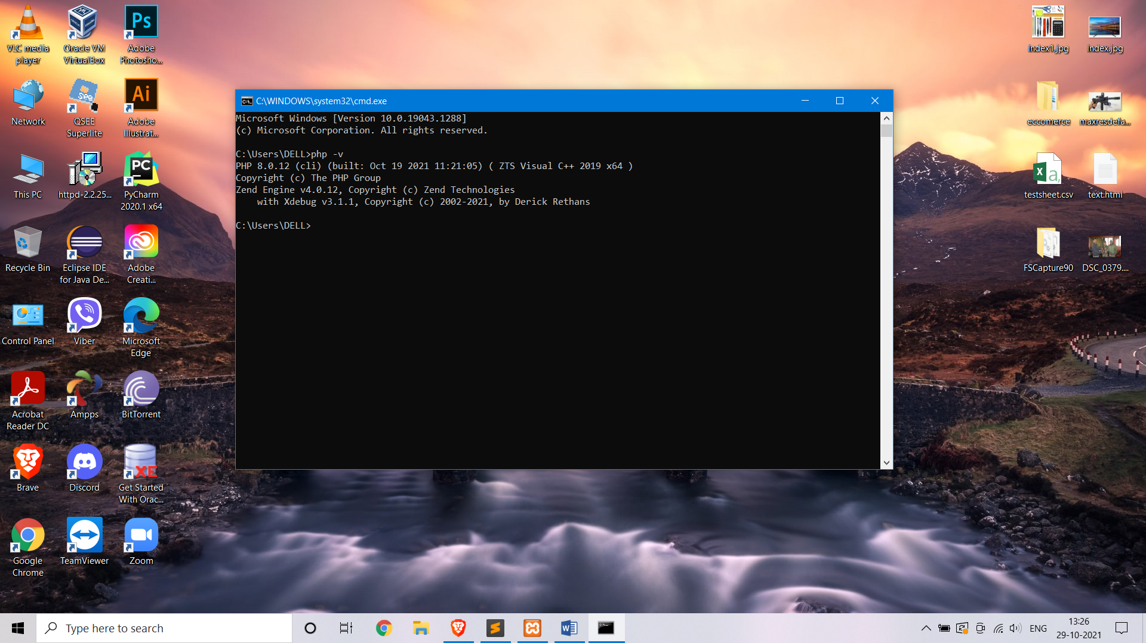

Fig.1 System PHP

**Composer**

The tool that is used for the dependency management in PHP is composer.

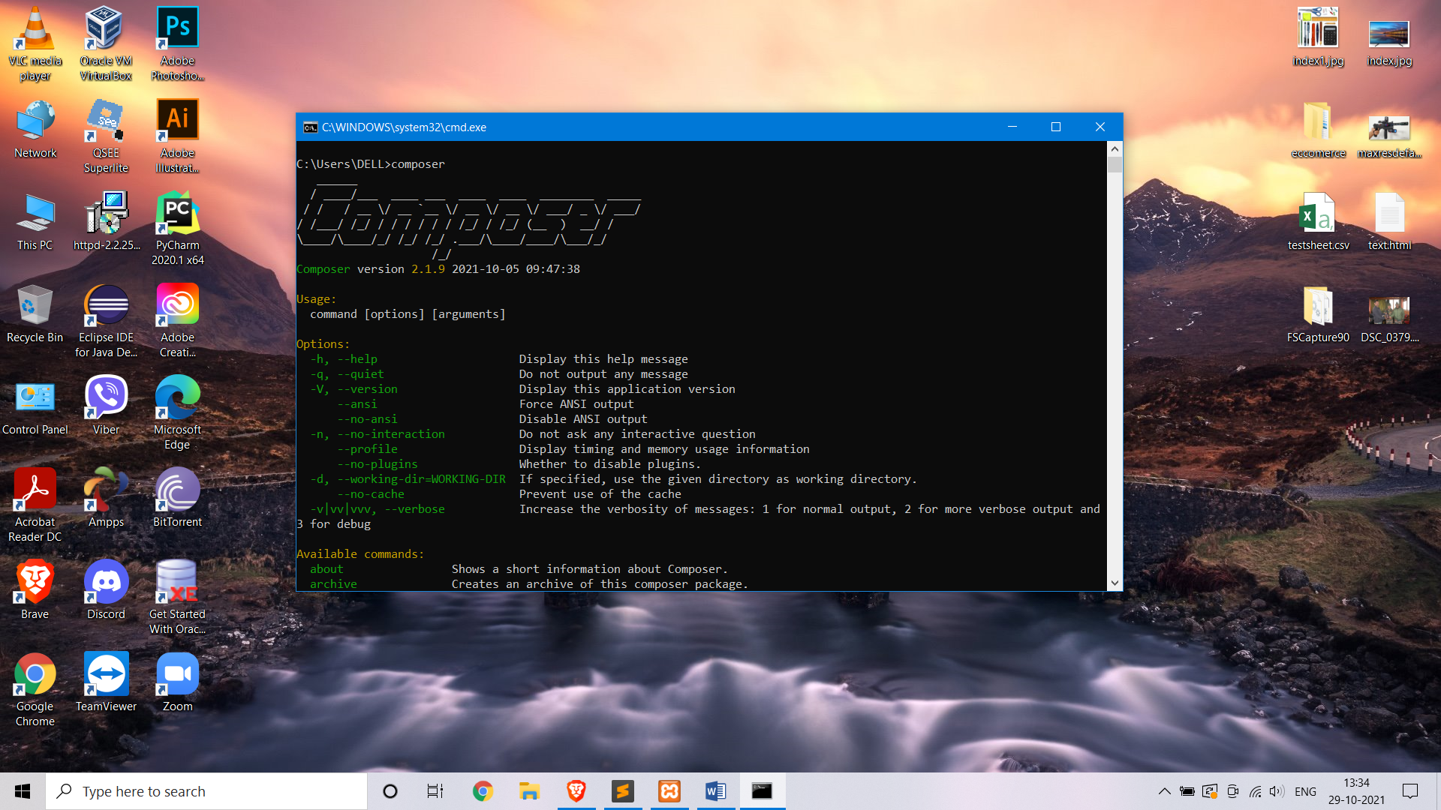

Fig.2 Composer

**XAMPP**

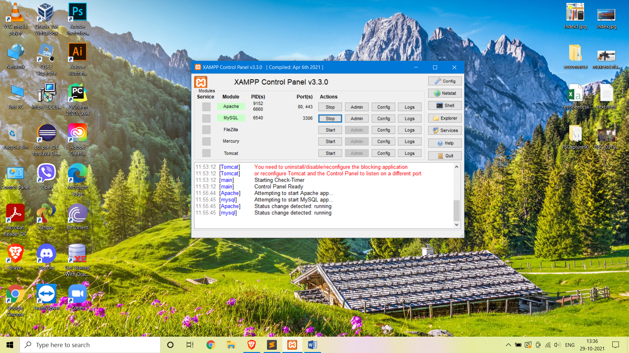

Fig.3 XAMPP

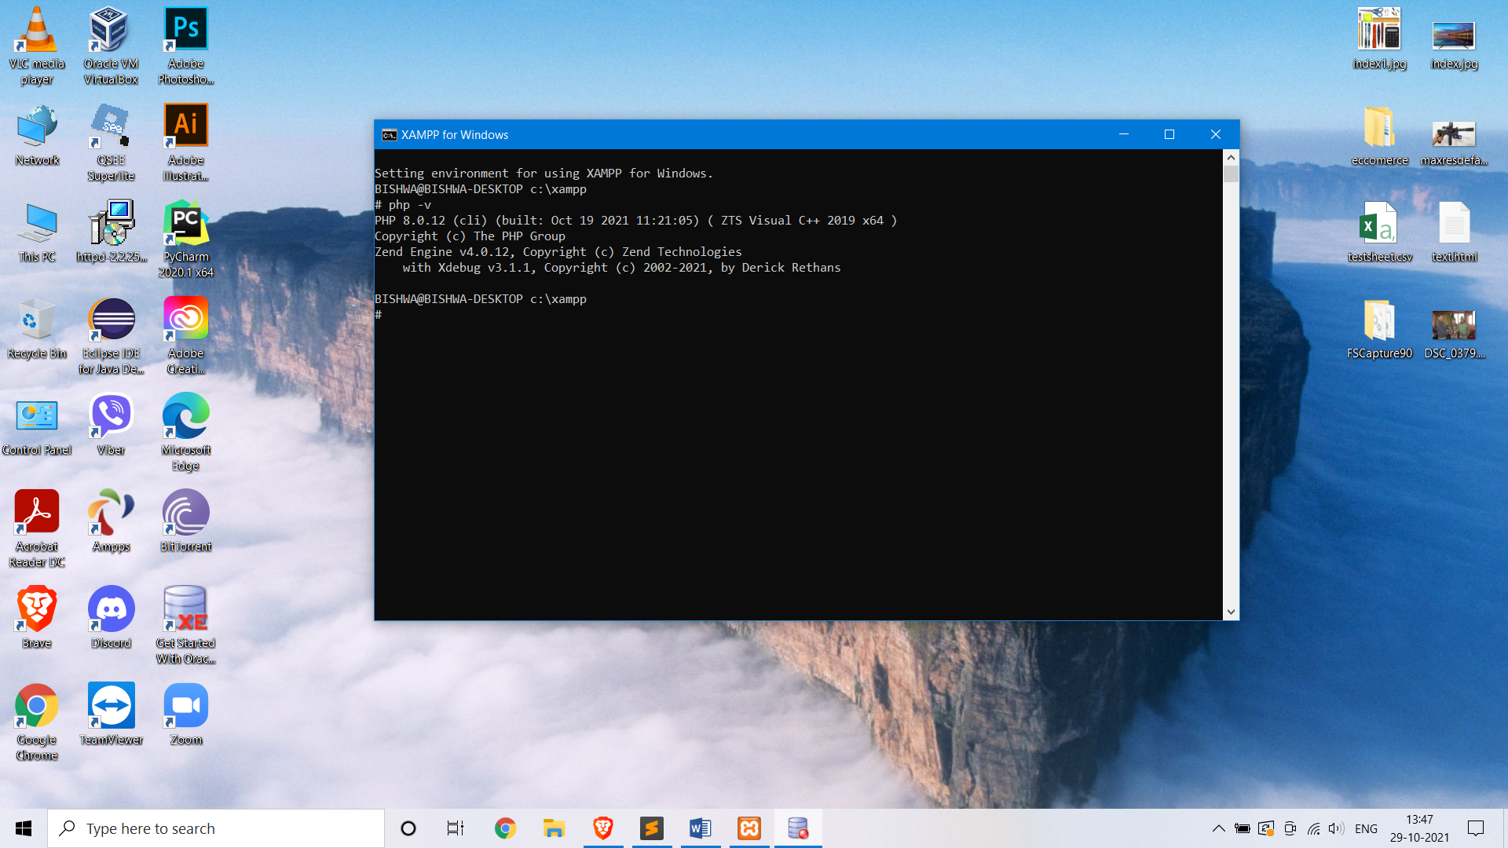

Fig.4 XAMPP PHP

**Code editor**

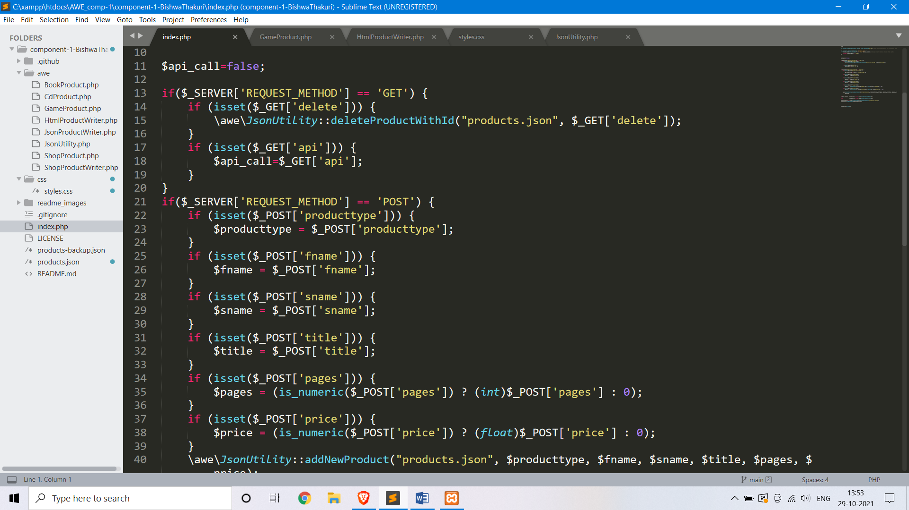

Fig.45 Code editor (Sublime)

**Xdebug**

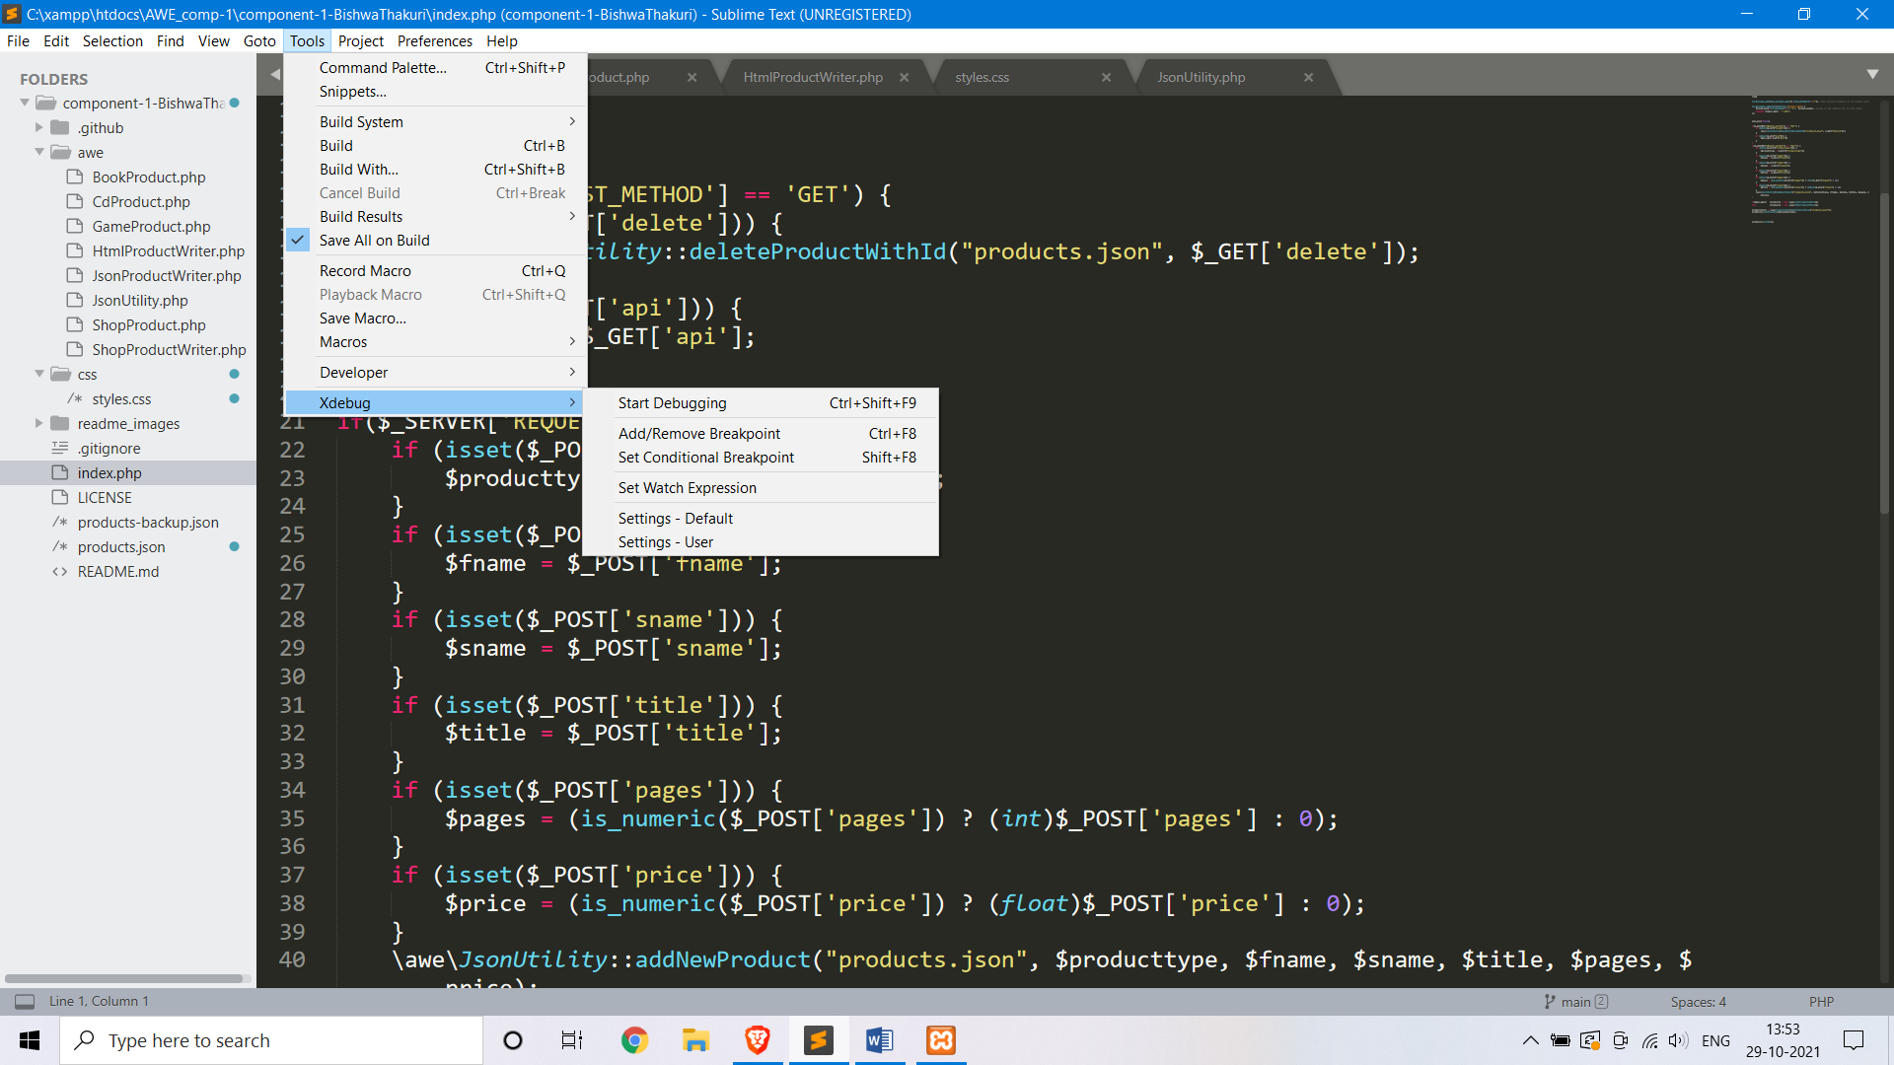

Fig.6 Xdebug in Sublime

**Version Controller**

Link: - https://github.com/tbc-bsc-l6/component-1-BishwaThakuri

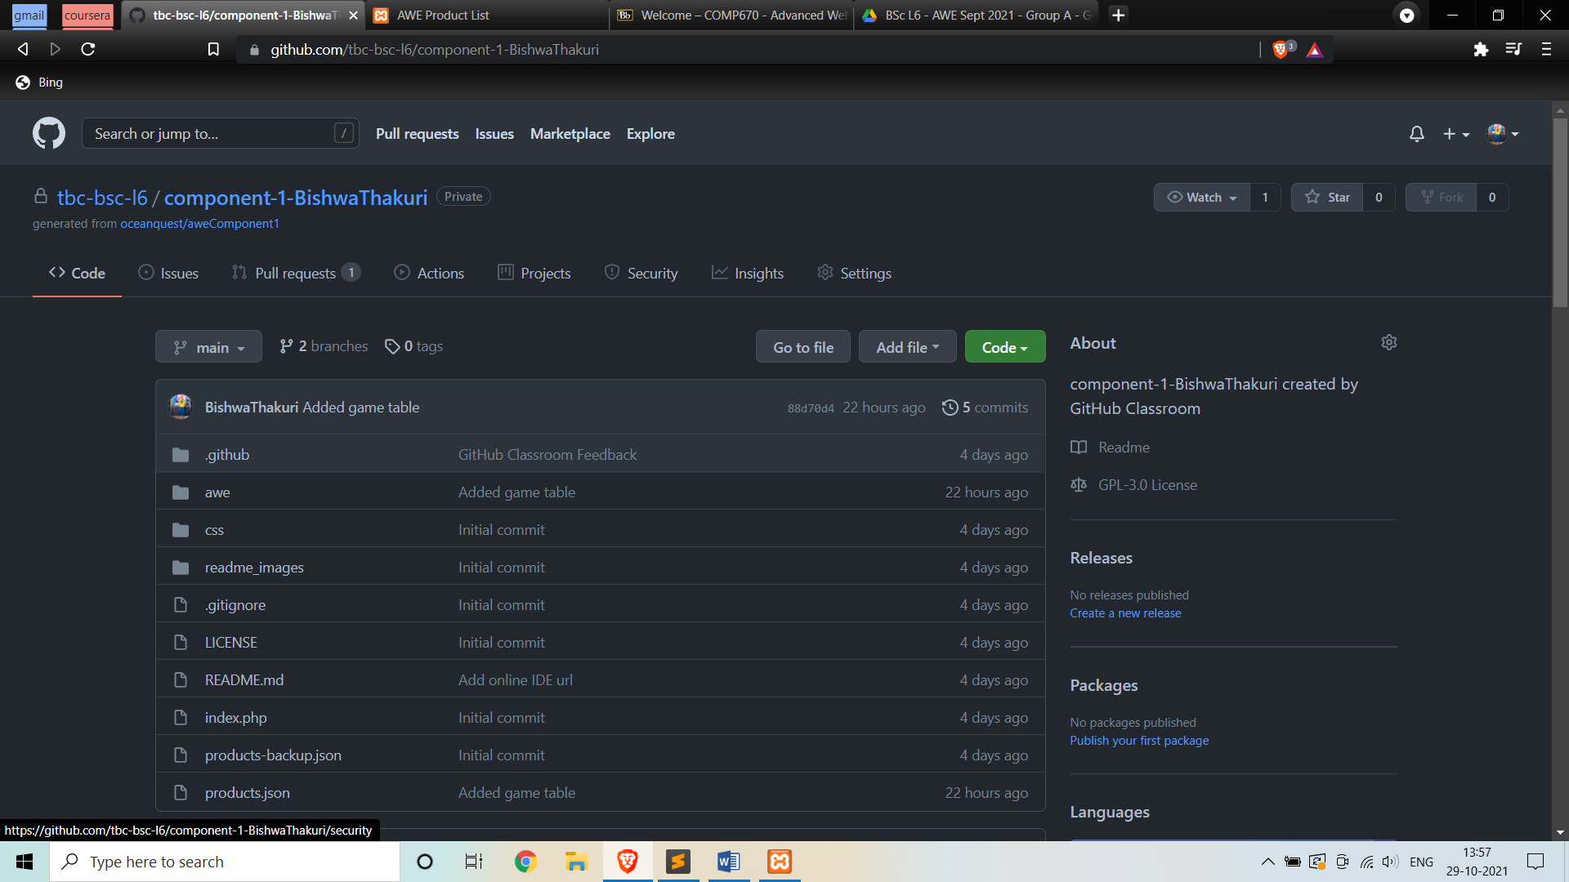

Fig.7 GitHub

**Component 1 Completed**

Here the game table is add and we can also insert data from the form into the game table. All the required filled for game is added to the form.

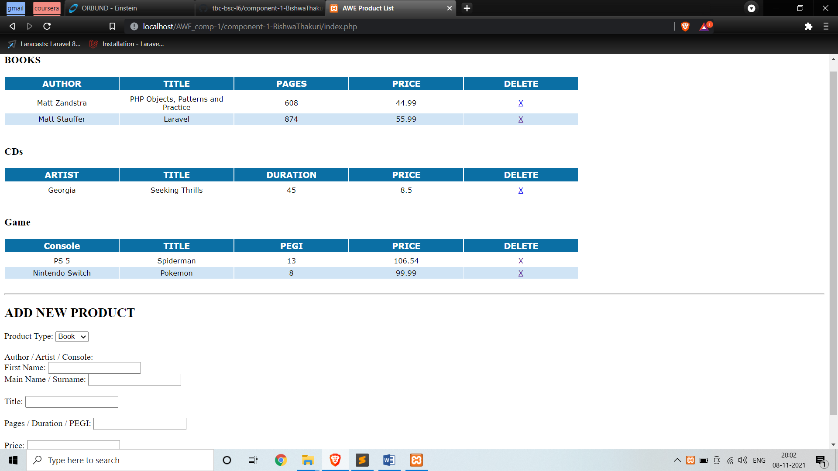

Here storing the data form the form into the json format for cd, book and game.

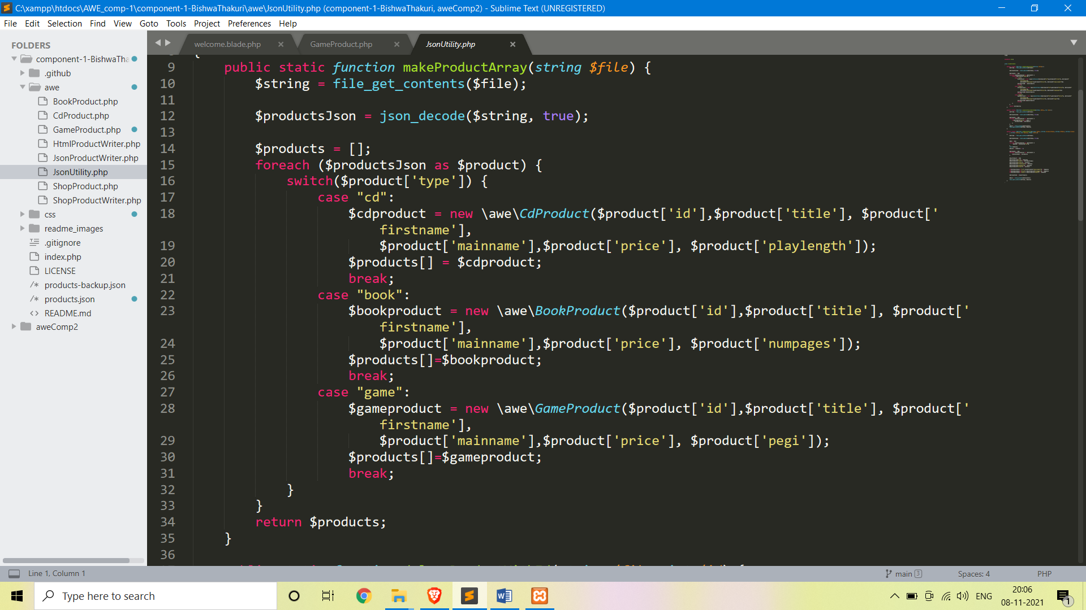

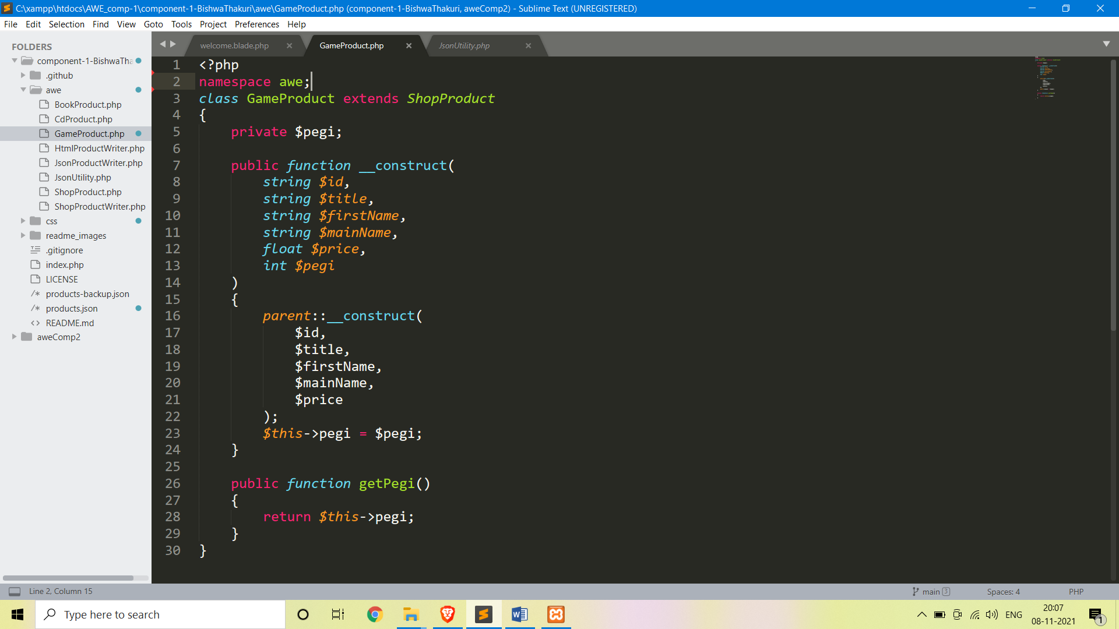

Here is the code for to fetch and display the data from json into the game table.

